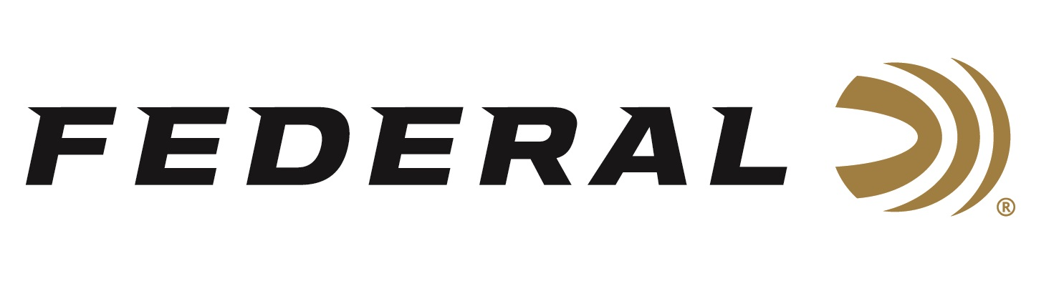

FOR IMMEDIATE RELEASE

Focused on Accuracy on “It’s Federal Season” Podcast

ANOKA, Minnesota – June 2, 2022 – Competitive shooter and Federal ambassador Krystal Dunn joins the “It’s Federal Season” podcast to talk about the shooting sports, the 2A movement, and her ownership of a beauty solon. A great discussion on the career path of a decorated competitive shooter who finds time to own and operate a business while maintaining a practice regimen to be an elite shooter.

Episode #35 “Focused on Accuracy”
https://www.federalpremium.com/this-is-federal/podcast/

“Krystal has a great story and very relatable as most competitive shooters have to balance a job that pays the bills and a passion that brings purpose,” said guest host Julie Golob. “Krystal shares tips on how to get involved in competitive shooting, some training tips and what types of matches a beginner should seek out.”

In the Tech Talk segment, Dunn reveals her thoughts on the age-old question in competitive shooting, where is the sweet spot between speed and accuracy? As Dunn expands into the rifle series, she also lists her favorite Federal cartridges for practice and competition.

For this episode, besides listening on the Federal Premium website or Talk North podcast network, you can also subscribe to Federal Ammunition’s YouTube channel (https://www.youtube.com/user/federalpremiumammo) and tune in for the discussion.

Federal Ammunition can be found at dealers nationwide or purchased online direct from Federal. For more information on all products from Federal or to shop online, visit www.federalpremium.com.

Press Release Contact: JJ Reich
Senior Manager – Press Relations
E-mail: VistaPressroom@VistaOutdoor.com

About Federal Ammunition
Federal, headquartered in Anoka, MN, is a brand of Vista Outdoor Inc., an outdoor sports and recreation company. From humble beginnings nestled among the lakes and woods of Minnesota, Federal Ammunition has evolved into one of the world's largest producers of sporting ammunition. Beginning in 1922, founding president, Charles L. Horn, paved the way for our success. Today, Federal carries on Horn's vision for quality products and service with the next generation of outdoorsmen and women. We maintain our position as experts in the science of ammunition production. Every day we manufacture products to enhance our customers' shooting experience while partnering with the conservation organizations that protect and support our outdoor heritage. We offer thousands of options in our Federal Premium and Federal® lines-it's what makes us the most complete ammunition company in the business and provides our customers with a choice no matter their pursuit.

